[](http://2.46.5.112:8004/website-webapp/common/preview_resource.action?id=c9668c58517b44f58bafe3315f474484%26type=jpg%26jcrVer=1.0)  
  
[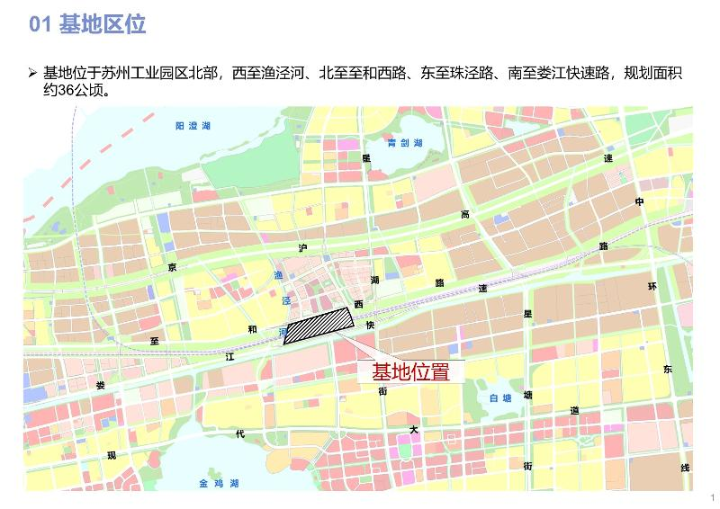](http://2.46.5.112:8004/website-webapp/common/preview_resource.action?id=71555850a27f4f2aa098764e7d71c121%26type=jpg%26jcrVer=1.0)  
  
[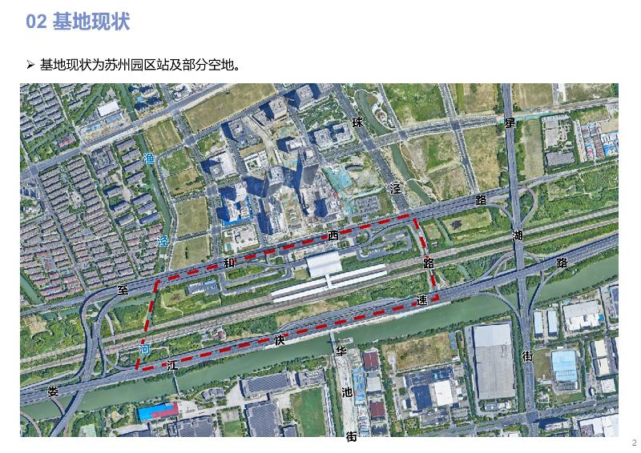](http://2.46.5.112:8004/website-webapp/common/preview_resource.action?id=dacfdc4552114609813966f340b49dc4%26type=jpg%26jcrVer=1.0)  
  
[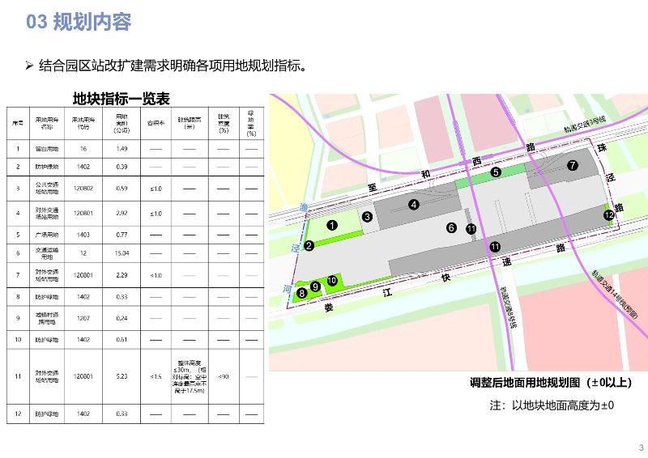](http://2.46.5.112:8004/website-webapp/common/preview_resource.action?id=6c1f5c70dbd74a79a763248e0b6e8eca%26type=jpg%26jcrVer=1.0)  
  
[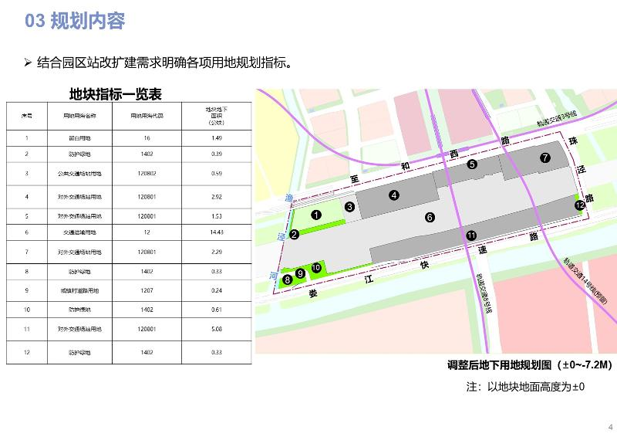](http://2.46.5.112:8004/website-webapp/common/preview_resource.action?id=3ba90b327ed94c95aad3c19583e943de%26type=jpg%26jcrVer=1.0)