[](http://2.46.5.112:8004/website-webapp/common/preview_resource.action?id=a51f87cebe0e48f59b0449218330b9d4%26type=jpg%26jcrVer=1.0)  
  
[](http://2.46.5.112:8004/website-webapp/common/preview_resource.action?id=9713a65a3b0945c59abde21112104d6f%26type=jpg%26jcrVer=1.0)  
  
[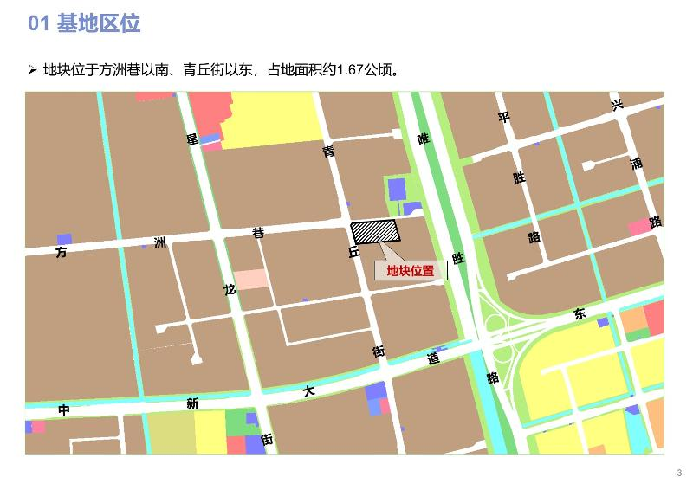](http://2.46.5.112:8004/website-webapp/common/preview_resource.action?id=c4dccb772b1949c7a5d33f4bafa4934f%26type=jpg%26jcrVer=1.0)  
  
[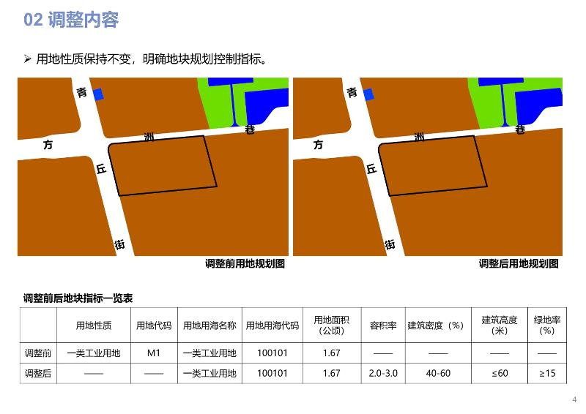](http://2.46.5.112:8004/website-webapp/common/preview_resource.action?id=8c7d76954e6b4463a7d4bb1ace573404%26type=jpg%26jcrVer=1.0)  
  
[](http://2.46.5.112:8004/website-webapp/common/preview_resource.action?id=e1f9cc978bd049968da3ef77e08bd972%26type=jpg%26jcrVer=1.0)  
  
[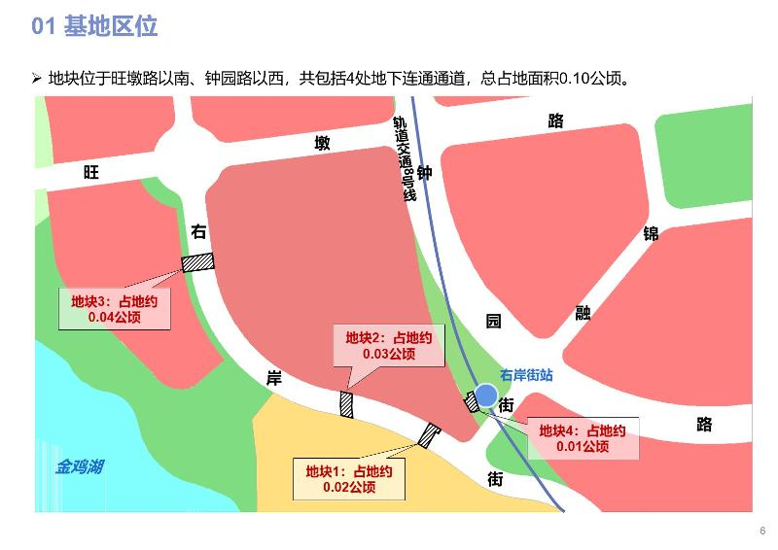](http://2.46.5.112:8004/website-webapp/common/preview_resource.action?id=c9953fdc80ae482cb068f9b29f2ca56a%26type=jpg%26jcrVer=1.0)  
  
[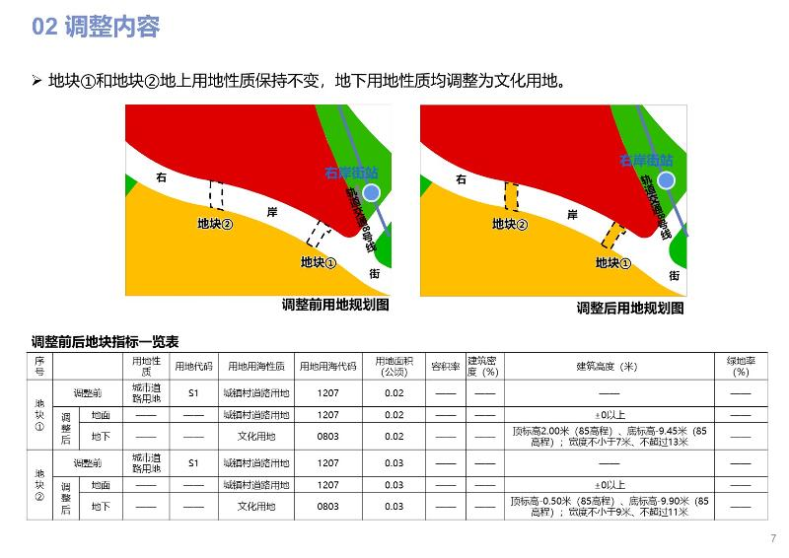](http://2.46.5.112:8004/website-webapp/common/preview_resource.action?id=0d4106d5d6b7417bb46613c8d935261e%26type=jpg%26jcrVer=1.0)  
  
[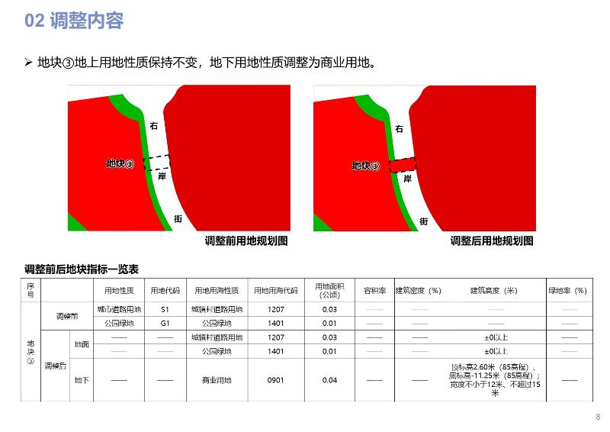](http://2.46.5.112:8004/website-webapp/common/preview_resource.action?id=24516040740d46c4bfda893498f92c60%26type=jpg%26jcrVer=1.0)  
  
[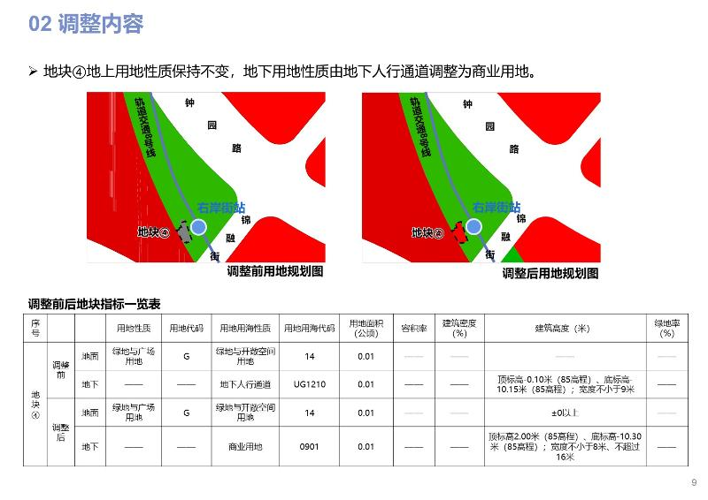](http://2.46.5.112:8004/website-webapp/common/preview_resource.action?id=98dd2a326be148158e5a16596875963a%26type=jpg%26jcrVer=1.0)  
  
[](http://2.46.5.112:8004/website-webapp/common/preview_resource.action?id=0085ed9b625a48c9b80d1101cf667e29%26type=jpg%26jcrVer=1.0)  
  
[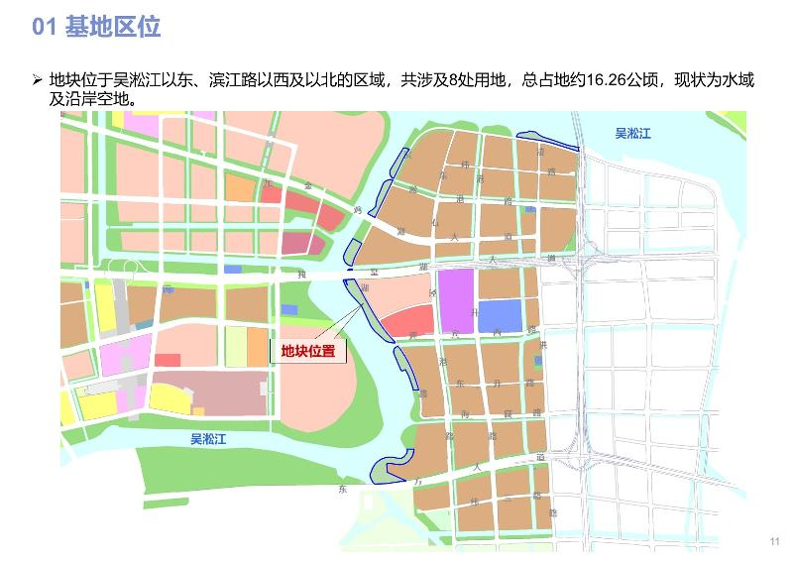](http://2.46.5.112:8004/website-webapp/common/preview_resource.action?id=7d766408556347609ddf9821f2eba099%26type=jpg%26jcrVer=1.0)  
  
[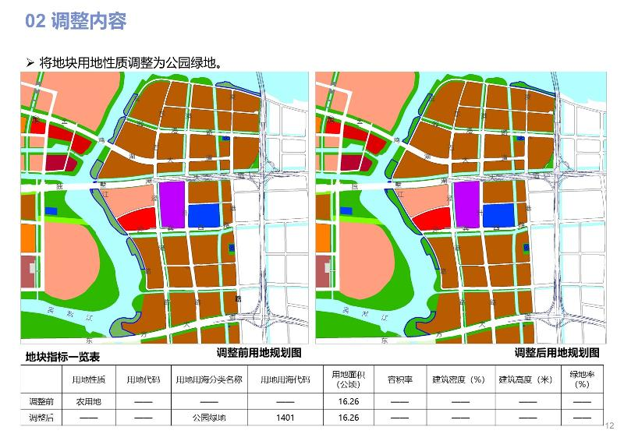](http://2.46.5.112:8004/website-webapp/common/preview_resource.action?id=bbb79d50b85f45d1b30327880f11c82a%26type=jpg%26jcrVer=1.0)  
  
[](http://2.46.5.112:8004/website-webapp/common/preview_resource.action?id=1f0d3c93d0594014b40bc296c5364a0b%26type=jpg%26jcrVer=1.0)  
  
[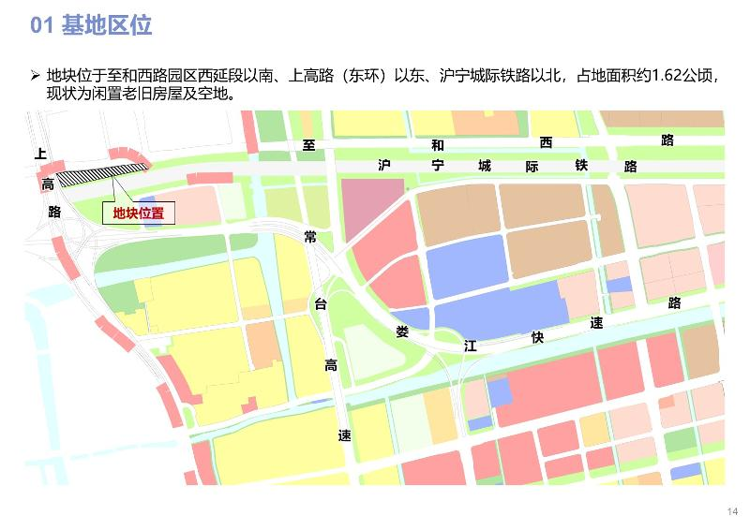](http://2.46.5.112:8004/website-webapp/common/preview_resource.action?id=60455aa212854c39985940a211e07001%26type=jpg%26jcrVer=1.0)  
  
[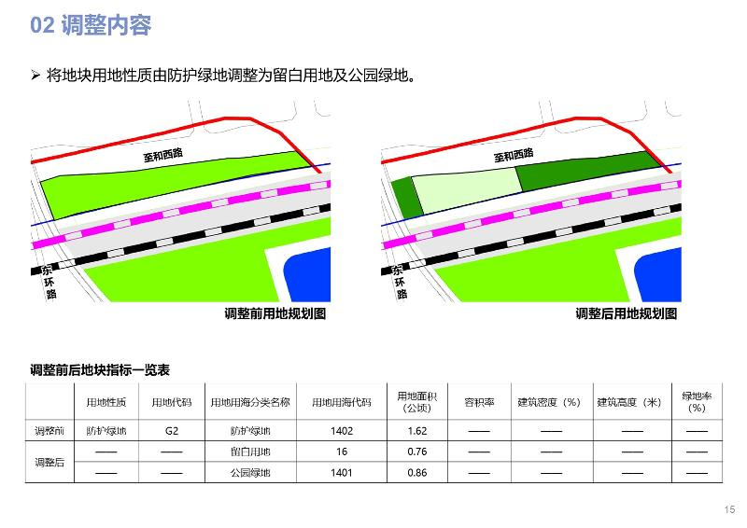](http://2.46.5.112:8004/website-webapp/common/preview_resource.action?id=e7c9c097712b4d2c974bc2fffc4a6a9c%26type=jpg%26jcrVer=1.0)