[](http://2.46.5.112:8004/website-webapp/common/preview_resource.action?id=910375dedef04e4db48b2ae3cf4b2689%26type=jpg%26jcrVer=1.0)  
  
[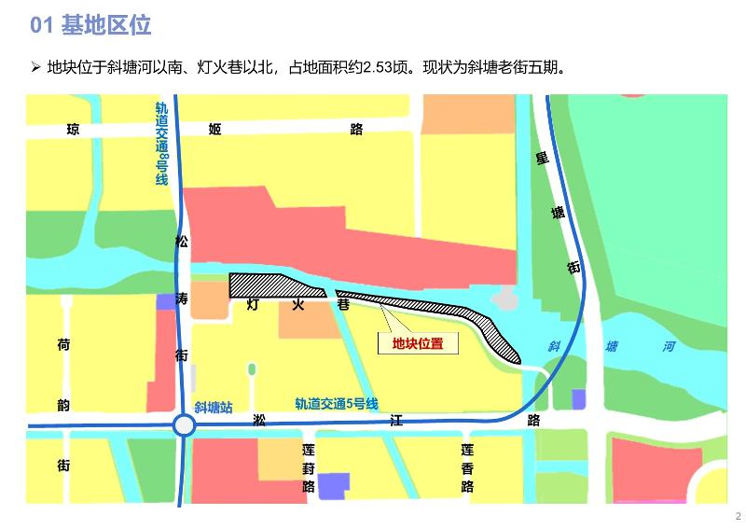](http://2.46.5.112:8004/website-webapp/common/preview_resource.action?id=cb26aa3728d14d8ca8c4e2edf5965248%26type=jpg%26jcrVer=1.0)  
  
[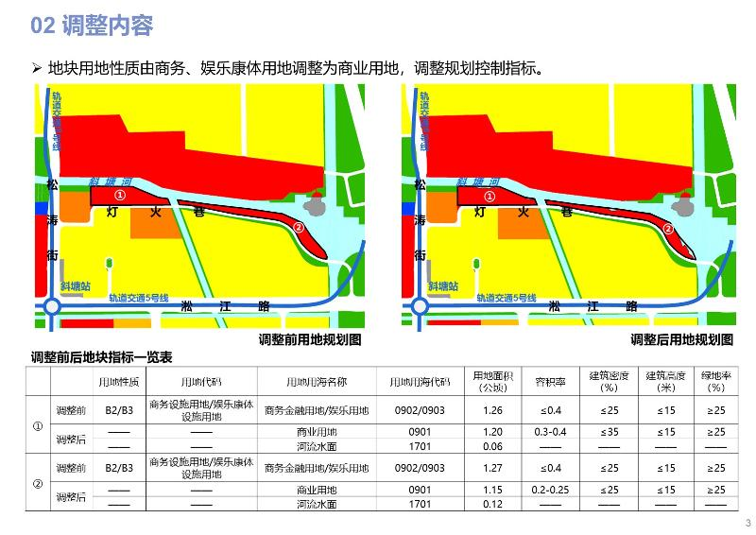](http://2.46.5.112:8004/website-webapp/common/preview_resource.action?id=cbbd23471d524174804d78981409437a%26type=jpg%26jcrVer=1.0)